Laboratory 3 - Semiconductor Circuits - Diodes Digital/ Physical Lab Book hybrid

**Half-Wave Rectifier work**

The Half-Wave Rectifier circuit was constructed and checked in kiCad, the implemented on a breadboard.

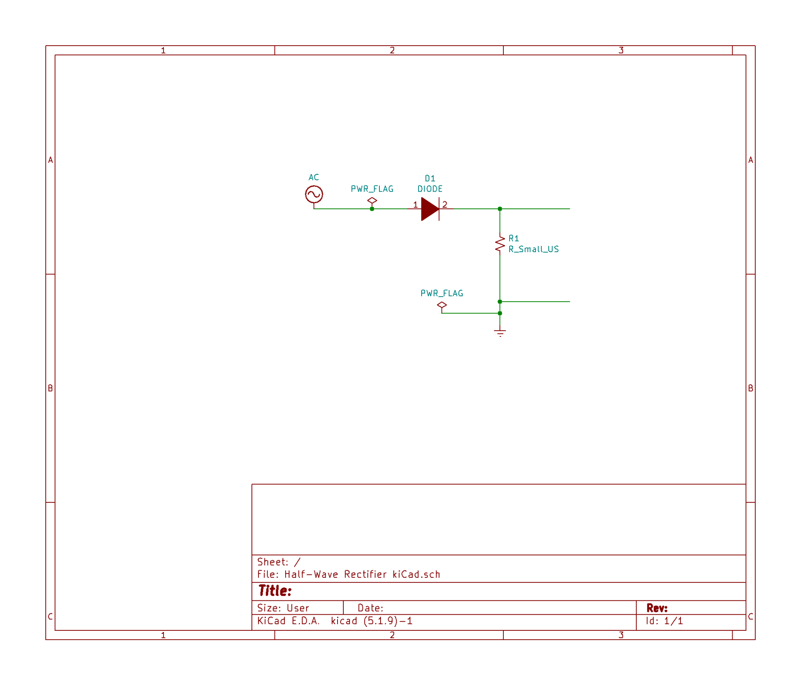

Two channels. One channel shows the generated signal, and the other channel shows the half-wave rectified signal.

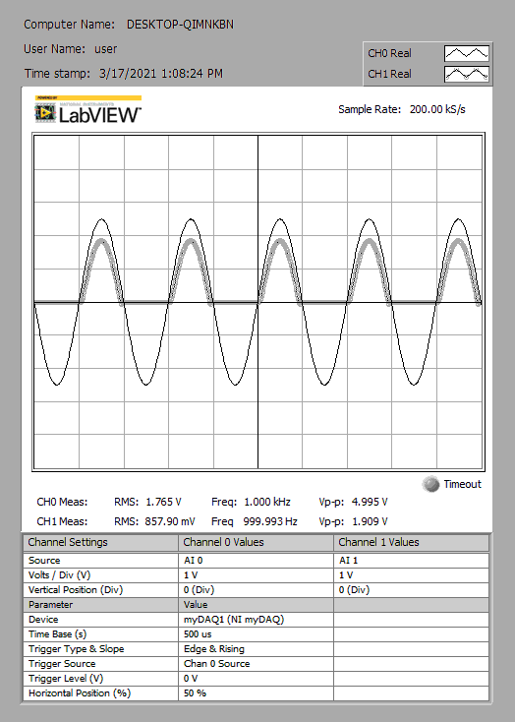

** It was **observed** that sinusoid lost most of its lower half, and the upper half peak was reduced.

Here is an FFT of the half-wave rectified signal

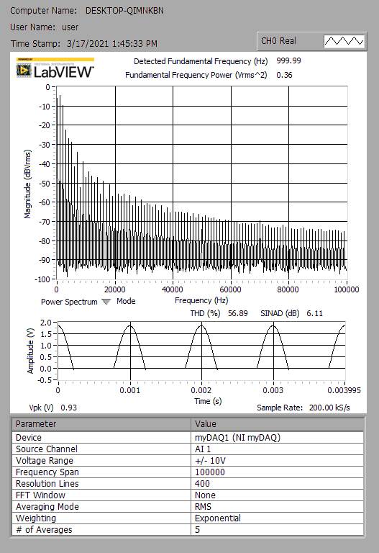

**Filtered half wave Rectifier**

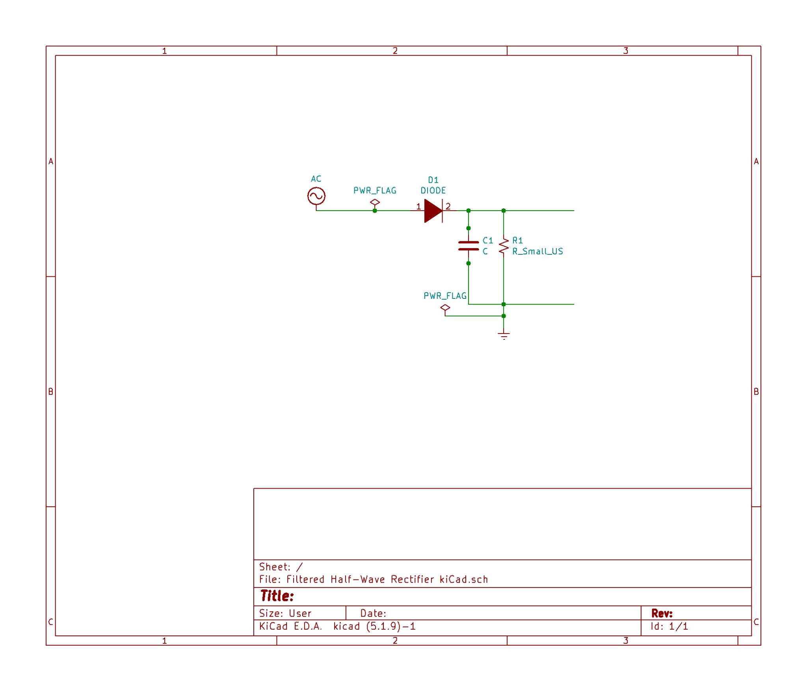

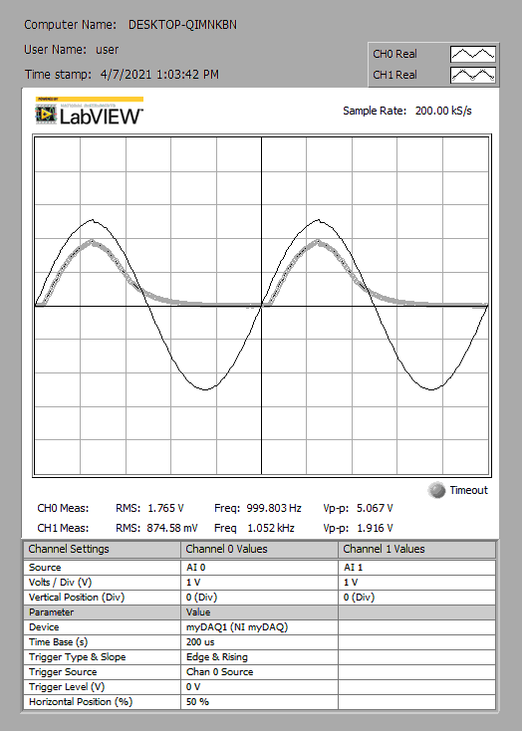

** It was **observed** that sinusoid lost its lower half, and the upper half peak was reduced **and** the right end of the upper cup deviated from the expected upper cup of the sin form because its points almost looked to follow an exponential decay, thus forming a left right asymmetry.

**Full-Wave Rectifier**

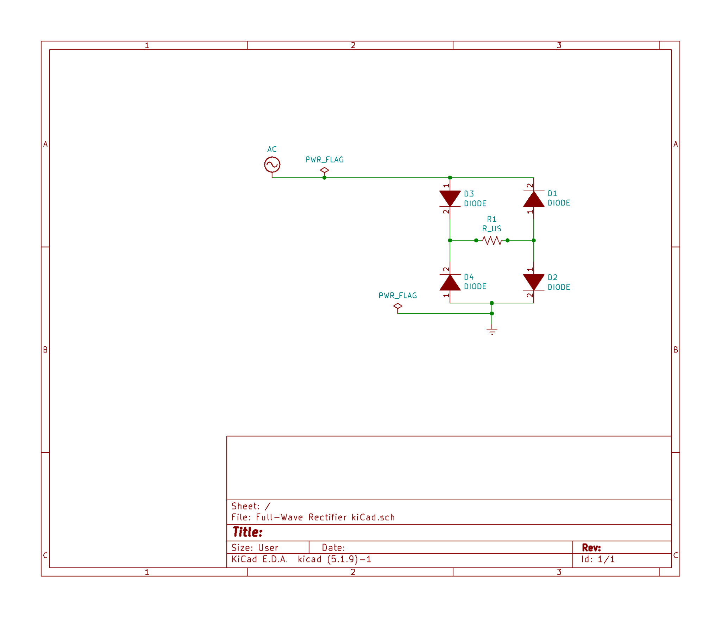

**Full-Wave Rectifier (A-B measurement) and FFT**

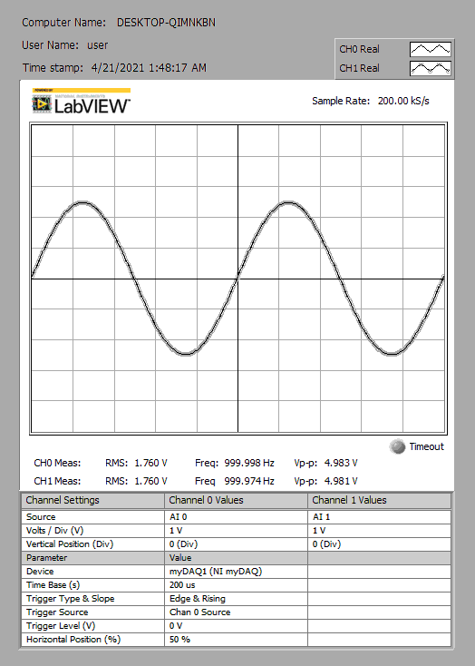

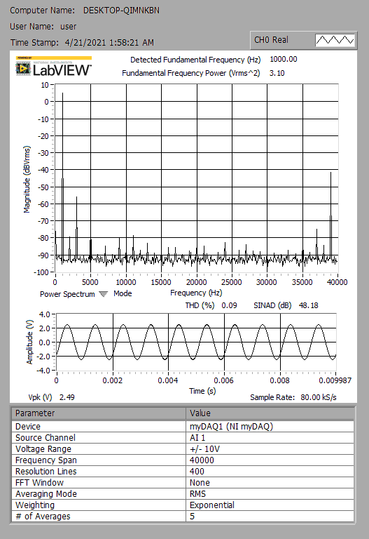

**Full-Wave Rectifier (C-D measurement) and FFT**

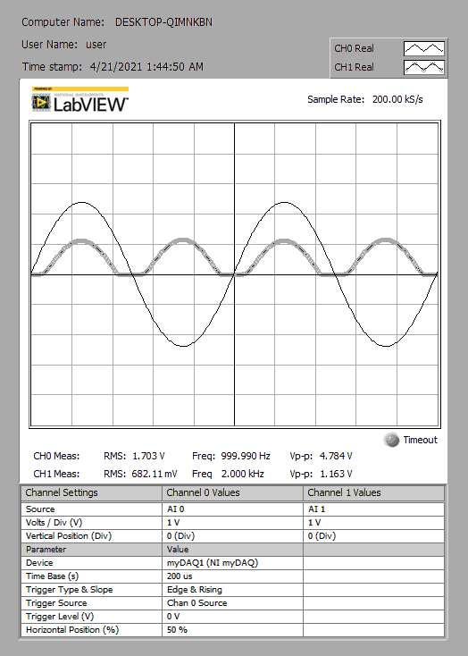

**Full-Wave Rectifier FFT**

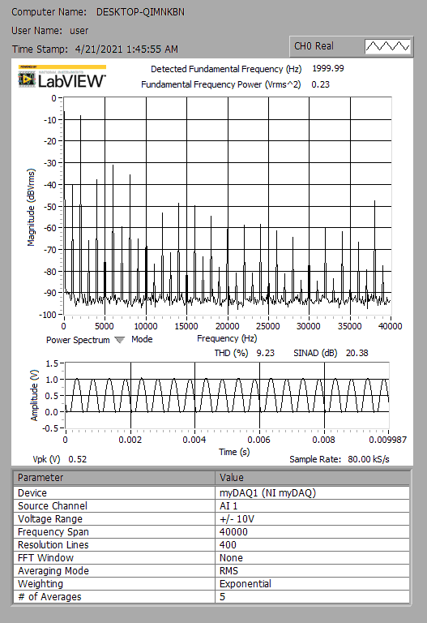

**Filtered Full-Wave**

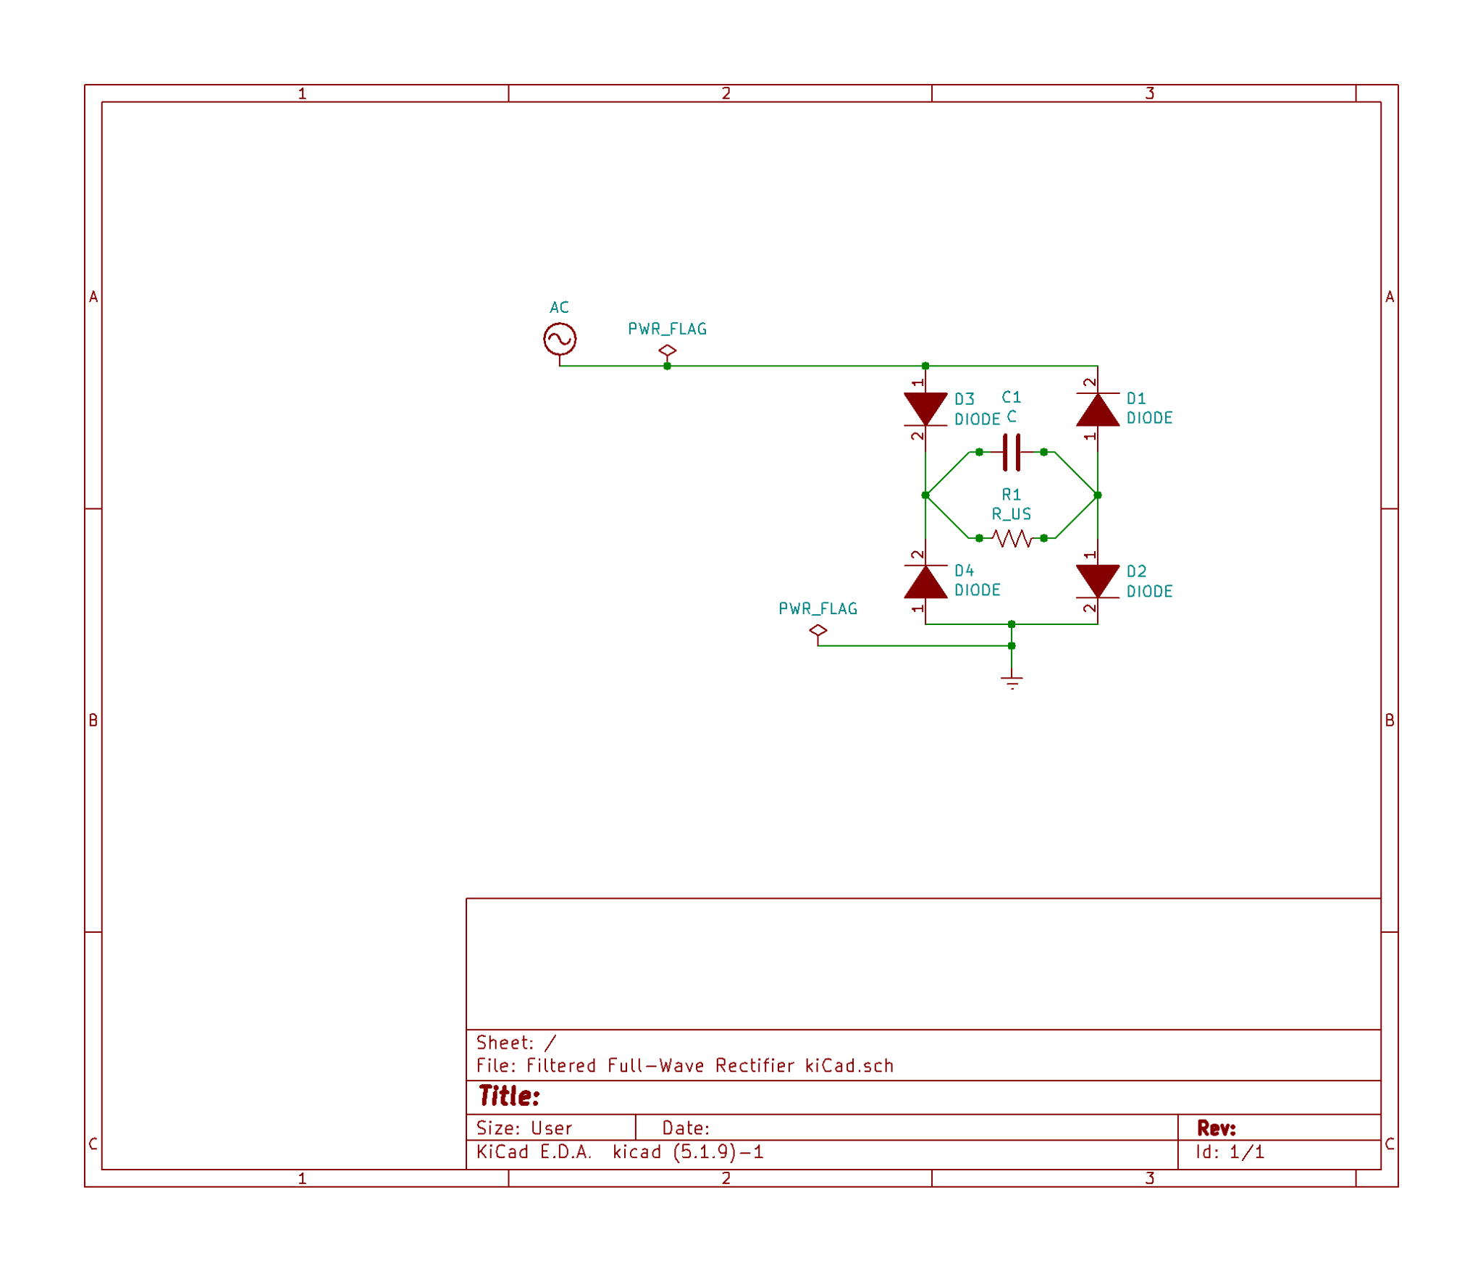

**Filtered Full-Wave Rectifier (A -B measurement) and FFT**

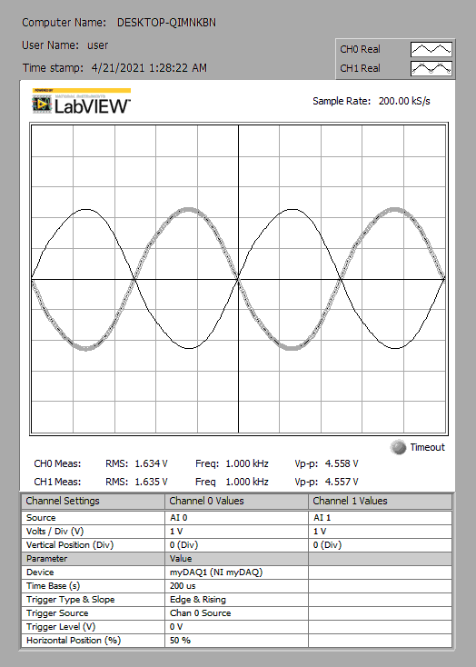

**Filtered Full-Wave (A-B) FFT**

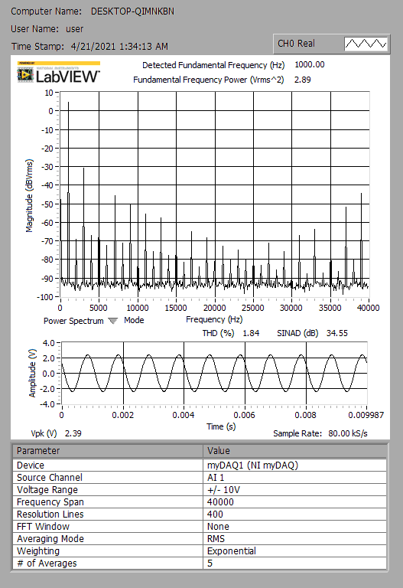

**Filtered Full-Wave Rectifier (C-D measurement) and FFT**

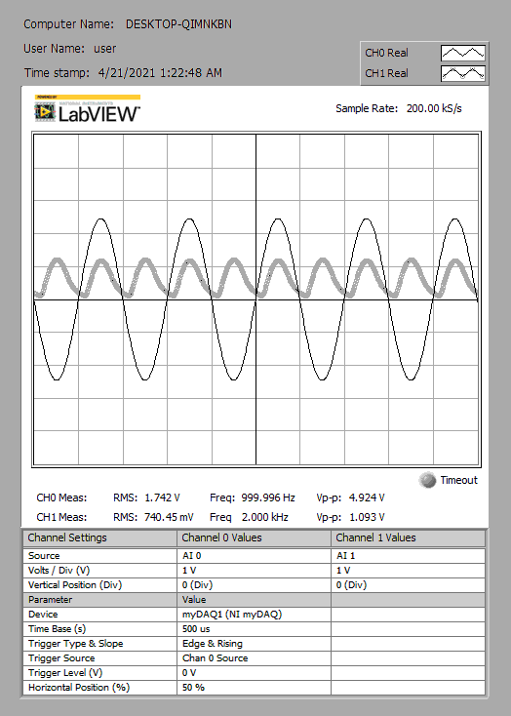

**Filtered Full-Wave (C-D) FFT**



Images of some of the more involved circuits are shown ; specifically the full wave and filtered full wave rectifiers are shown , in the configuration where measurements were taken. Below are the constructed Filtered full wave rectifier, followed by the full wave rectifier.

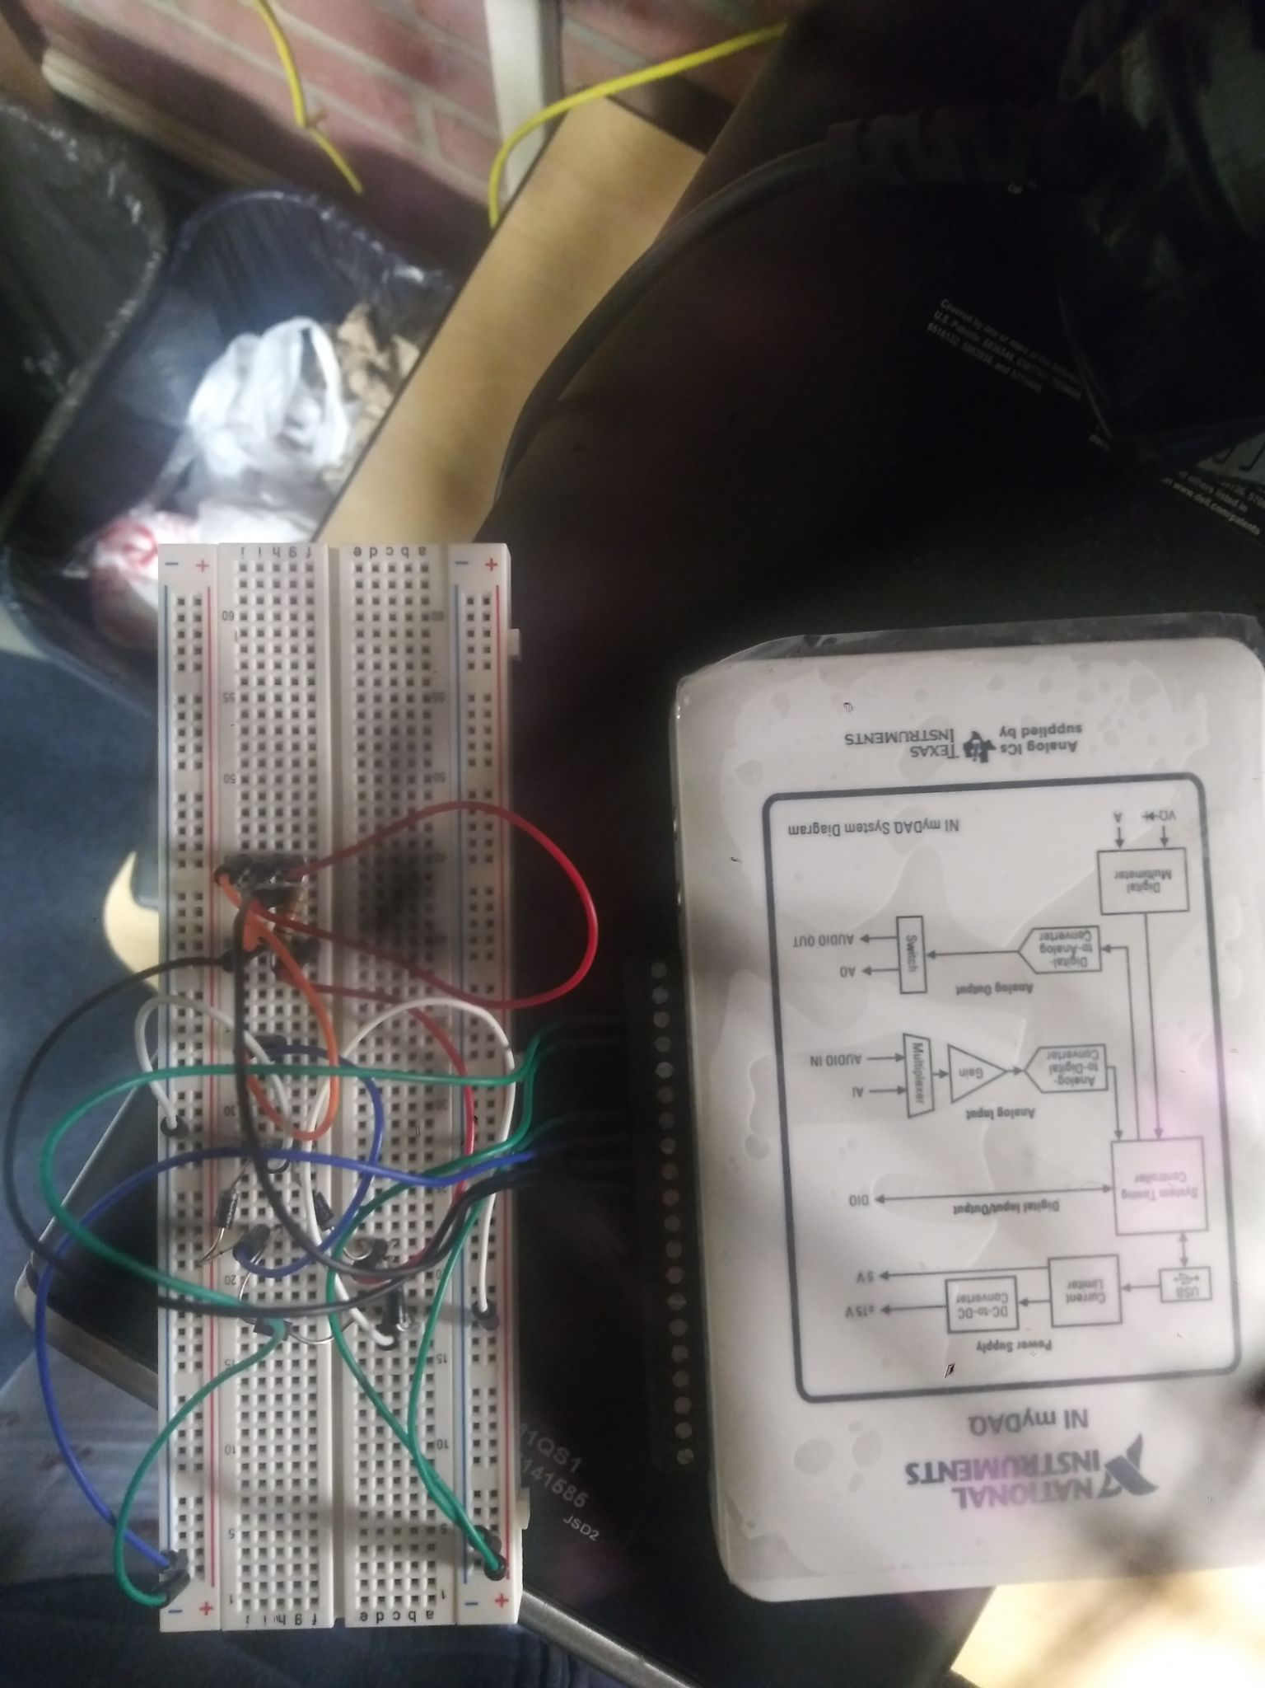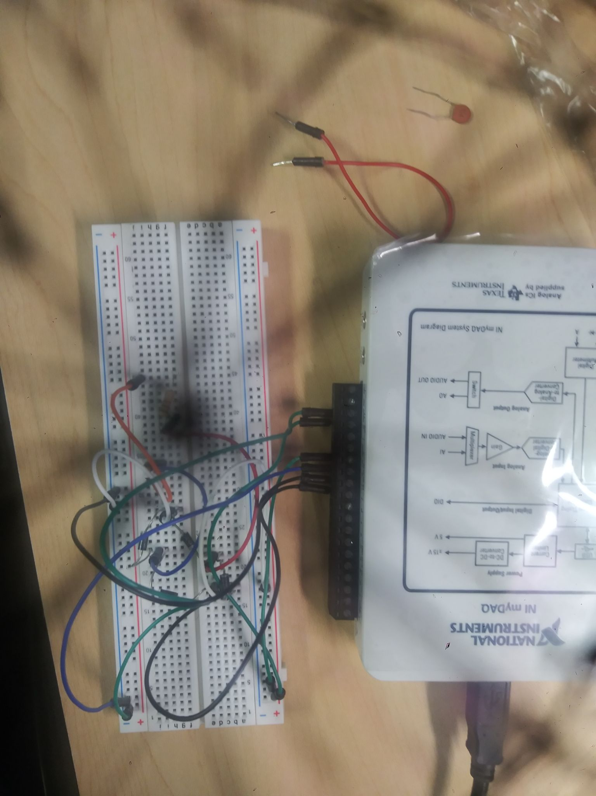

**Diode Clamp**

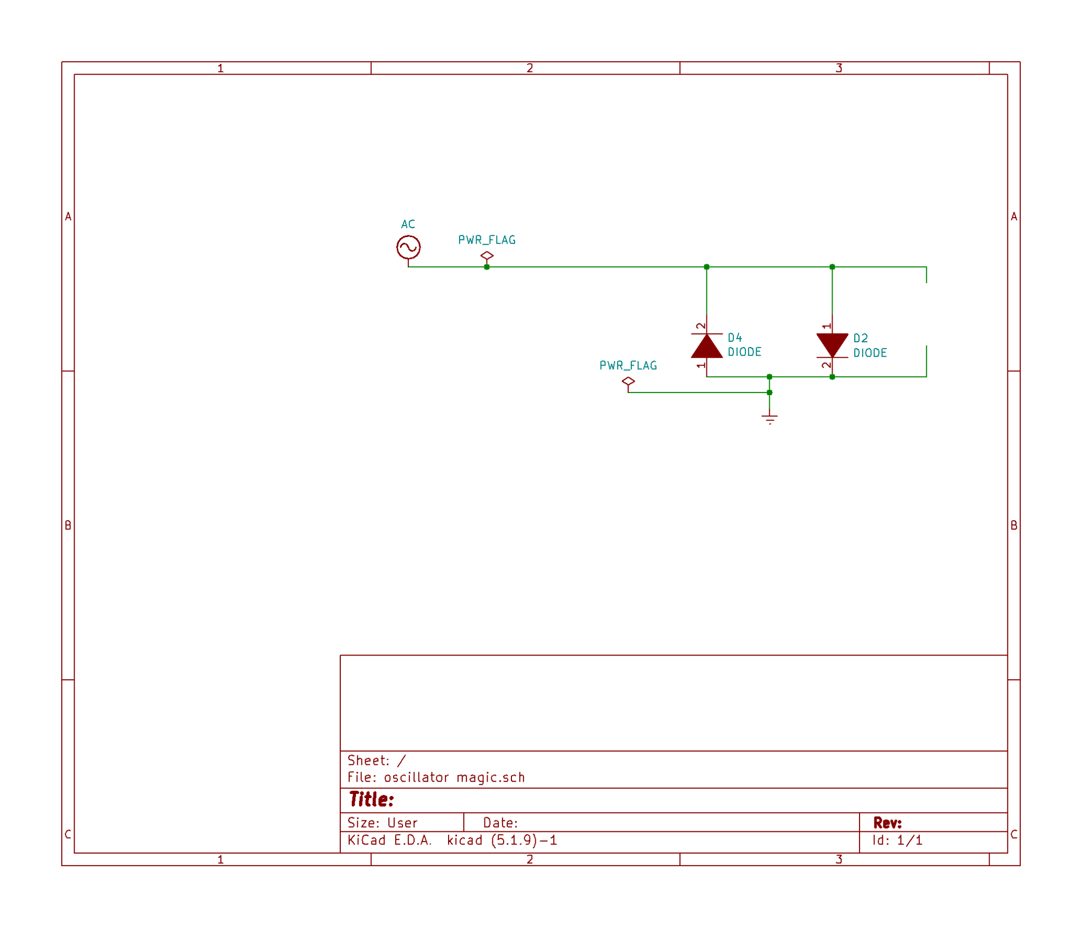

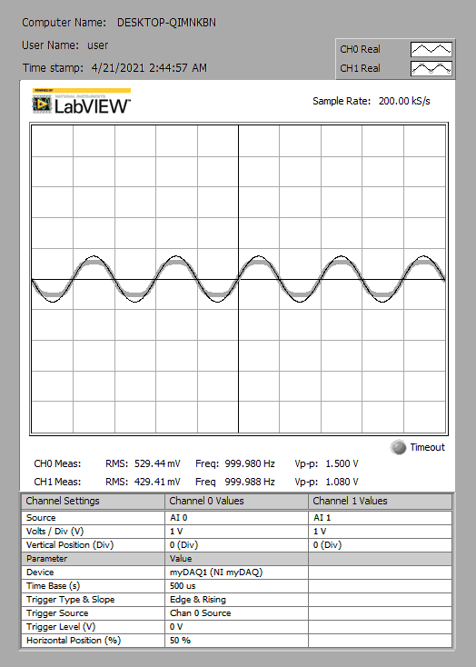

**\*\*** It was **observed** that the voltage peaks were clipped

**Image of constructed circuit**

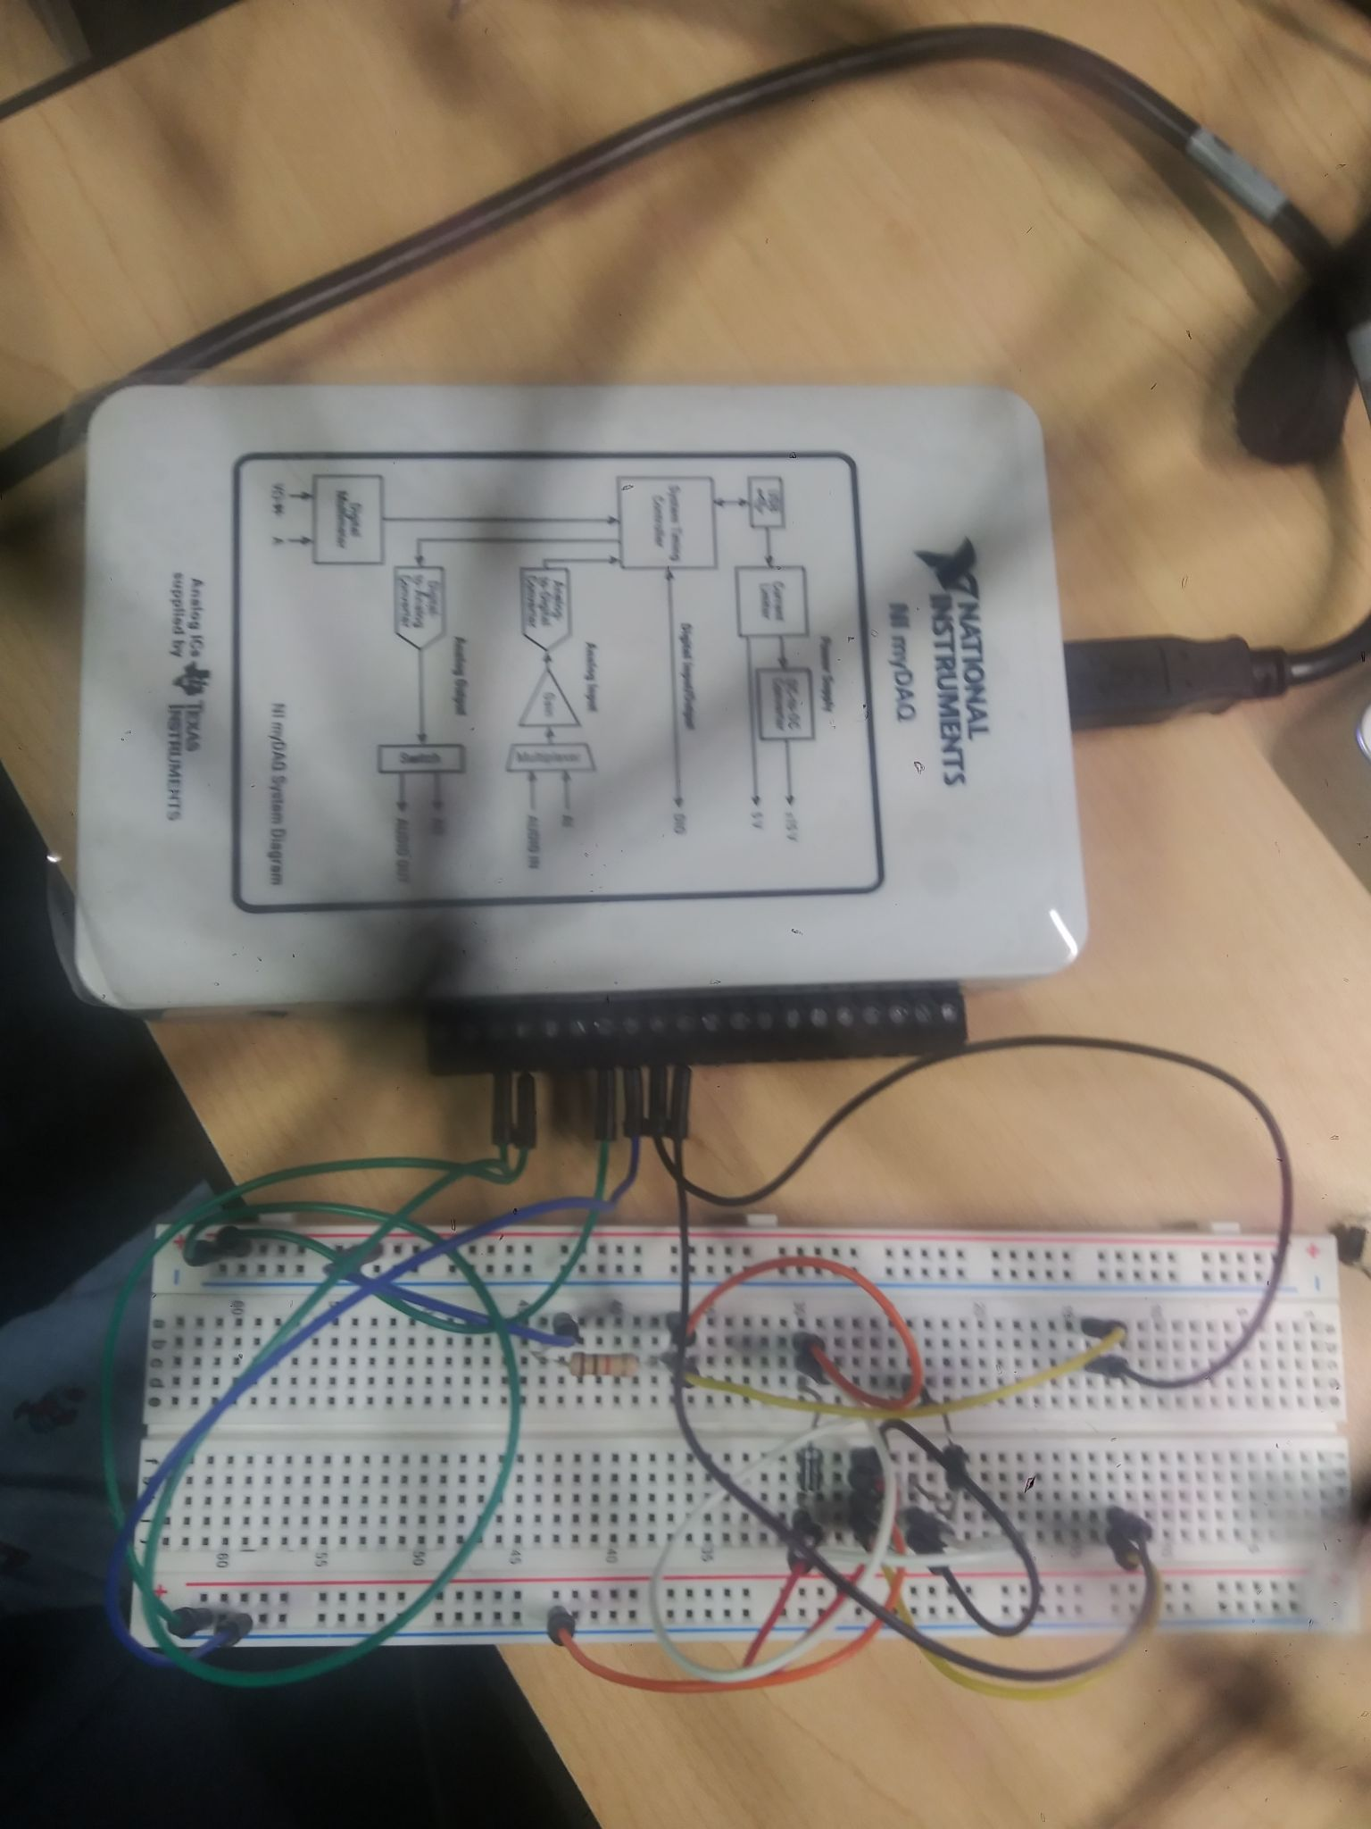

**Data and plot**

|  |  |  |  |
| --- | --- | --- | --- |
| **Start Frequency** | **Stop Frequency** | **Input Vpp** | **Output Voltage** |
| **100** | **1000** | **0** | **0** |
| **100** | **1000** | **0.1** | **0.1** |
| **100** | **1000** | **0.2** | **0.2** |
| **100** | **1000** | **0.3** | **0.3** |
| **100** | **1000** | **0.4** | **0.4** |
| **100** | **1000** | **0.5** | **0.5** |
| **100** | **1000** | **0.6** | **0.6** |
| **100** | **1000** | **0.7** | **0.69** |
| **100** | **1000** | **0.8** | **0.78** |
| **100** | **1000** | **0.9** | **0.86** |
| **100** | **1000** | **1** | **0.92** |
| **100** | **1000** | **1.1** | **0.97** |
| **100** | **1000** | **1.2** | **1.01** |
| **100** | **1000** | **1.3** | **1.04** |
| **100** | **1000** | **1.4** | **1.06** |
| **100** | **1000** | **1.5** | **1.08** |

